CTEC601 2024 S2

Assignment 2 – A Synthetic Reality

# The Strip

# Team Members

|  |  |  |  |
| --- | --- | --- | --- |
| Name | Contribution description | Contribution weight | Signature |
| Fletcher Poole | Everything | 100% |  |

# Description

Roughly describe the project:

* Why did you decide for the location/scene/etc.?
  + I decided to do Fallout New Vegas strip. Chose this because New Vegas is one of my favourite games and I thought it’d be kind of cool to almost remake it in a new engine as its about 15 years old.
* What core assets did you need for this project?
  + All the assets you see in the scene, most custom with some primitive planes being used on the ground and the Unity Landscape system being used for the grass areas.
* How did you record/create/process those core assets?
  + I went into the game and recorded footage of me walking around the strip examining the assets and capturing the sound which I will attempt to replicate.
* Did you break down the project into steps/blocks? If so, which?
  + I decided to start with the ground/gate details first. This way I can create the scenes basic length and width. After that I started on the more complex models like the casino/tower/signage.

# Sketches/Screenshots

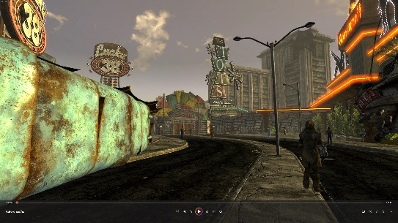

# Changelog/Diary

## 16/4/2024

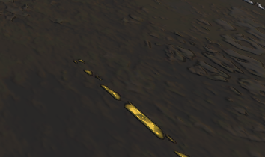I knew in order to get this project done I had to start early. So today I made a start on the roads with some grimy dark textures/materials and somewhat intense normal maps.

## 19/4/2024

Today I added some curbs and paths to the scene.

## A screenshot of a video game Description automatically generated21-23/04/2024

These last few days I’ve been working on getting the gates setup as theres quite a lot to them.

I also added a grass landscape as its easier than worrying about tiling materials.